May 18th 2017

Inspiring Jewish, Christian & Muslim Women Building Trust & Understanding

Emerging from bumper-to-bumper Friday traffic into the quiet peace of the Don Bosco Centre, Lysterfield, we tuned into some of the most basic and enjoyable of human experiences: meeting new people, receiving hospitality, sharing inspiring stories, sharing faith and making new friends at the annual Jewish Christian Muslim Association’s Inspiring Women of Faith Women’s Conference 12-14th May 2017.

As a group of women from Judaism, Christianity and Islam we represented the variety and depth within each faith tradition. Over the conference we were able to observe each other’s prayer rituals lead by members of each of the religious groups. It was carefully planned to fit into the times of traditional weekly/daily routines and in sharing and experiencing each other’s holy days of Friday, Saturday and Sunday we got to learn about each other’s practices and encounter deeply held beliefs.
Hearing from women different from ourselves was a gift and served to enrich our own faith and life journeys. Sometimes challenged by stereotypes and sensitivities we were able to speak with real honesty and reach out to others with genuine compassion. It was a time to share and reflect on things we don’t often have time to examine.
We also heard from keynote speakers about inspiring women of the Abrahamic faiths, women from each of our religious traditions and from women living out their faith today. We heard about Beruriah, the second century Jewish scholar followed by the highly spiritual Christian woman Hildegard of Bingen, and discovered that Aisha, second wife of the Prophet (pbuh), was a deeply spirituality women and “scholar of scholars”.
For a text based session on “Miriam and Mary” Dr Helen Light, JCMA President, presented a Jewish insight into the life of Miriam, the sister of Moses and Aaron, who was a prophet and first appears in the Book of Exodus. Professor Mary Coloe presented a Christian perspective of Mary and Sherene Hassan presented from a Muslim perspective how important Mary (Maryam) is in the Islamic faith inspiring and connecting us as women of faith.

An important part of the conference were the times of open and safe discussion in small groups, the larger group and over break times. With these opportunities we were able to relate to each other with deeper levels of trust and understanding, inspiring each other to live as positive women of faith in a diverse and interconnected world.
Article written by: Ginette Everest, JCMA Executive Officer and Sister Elizabeth Young, Sisters of Mercy.

To find out more about the Jewish Christian Muslim Association and our events and womens conferences call Ginette on (03) 9287 5590 or visit our website: jcma.org.au or Facebook page https://www.facebook.com/jcmaonline

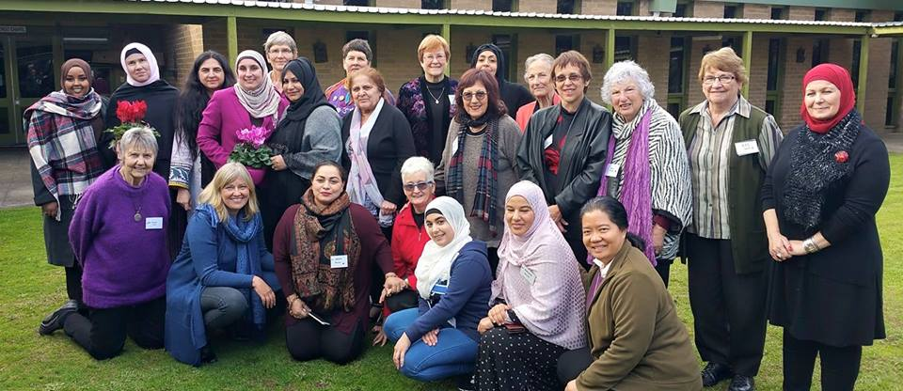
Picture: JCMA Womens Conference 12th -14th May 2017 – Inspiring Women of Faith
